LAB Manual

PART A

(PART A : TO BE REFERRED BY STUDENTS)

**Experiment No.04**

**A.1 Aim:**

Create a project feasibility report by covering the following points.

* Technical Feasibility – Can we built it
* Economic feasibility – Should we build it.
* Organizational Feasibility - Is the project strategically aligned with the business?

**A.2 Prerequisite:**

Understanding of Technical, Economical and organizational Feasibility.

**A.3 Outcome:**

**After successful completion of this experiment students will be able to:**

Create a project feasibility report by covering following points.

* Technical Feasibility – Can we built it
* Economic feasibility – Should we build it.
* Organizational Feasibility - Is the project strategically aligned with the business?

**A.4 Theory:**

**Steps for conducting Economical Feasibility**

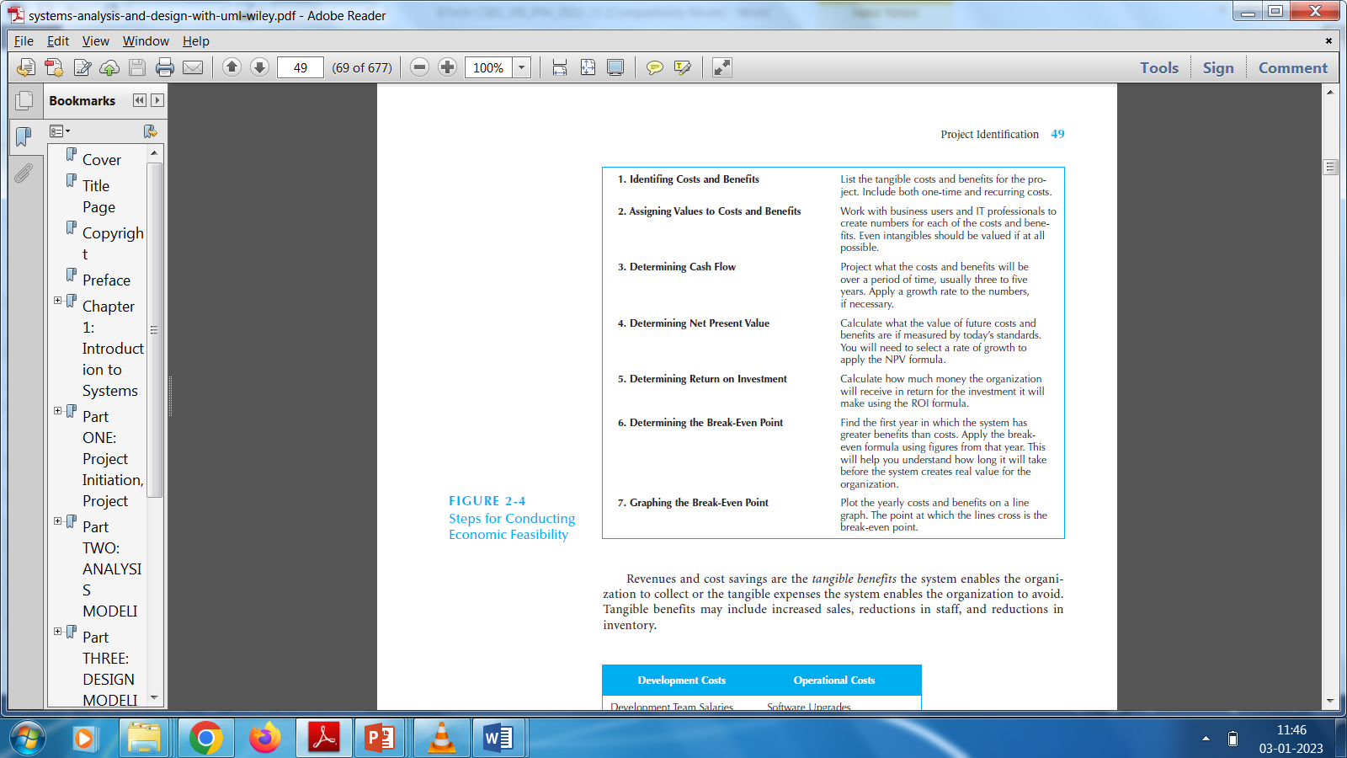

**A.5 Procedure/Algorithm:**

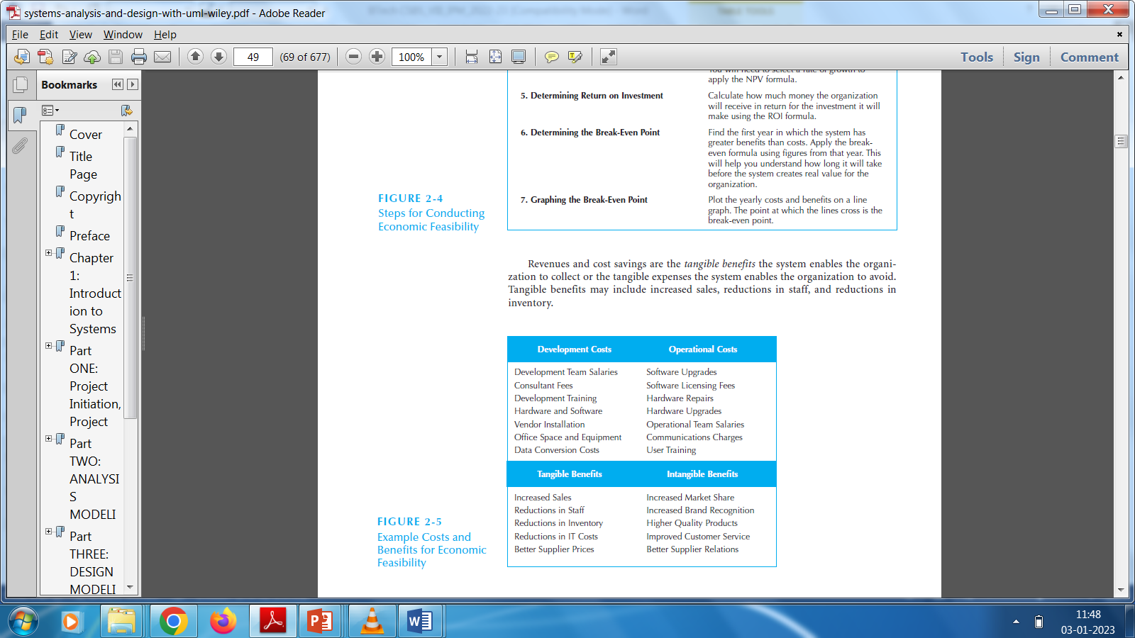

PART B

(PART B : TO BE COMPLETED BY STUDENTS)

***(Students must submit the soft copy as per following segments within two hours of the practical. The soft copy must be uploaded on the Blackboard or emailed to the concerned lab in charge faculties at the end of the practical in case there is no Black board access available)***

|  |  |
| --- | --- |
| Roll No. A016,A018,A022 | Name: Varun K, Simran K, Kartik P |
| Class : B.Tech CsBs | Batch : 1 |
| Date of Experiment: 29-01-2023 | Date of Submission 29-01-2023 |
| Grade : |  |

**B.1 Answers of Task to be written by student:**

***(Paste your answers completed during the 2 hours of practical in the lab here)***

1. Identifying Costs and Benefits:

Costs:

* Development costs, including coding, design, and testing
* Marketing costs to promote the platform and attract users
* Operational costs to manage the platform, including website hosting, customer service, and order fulfillment

Benefits:

* Increased revenue from online sales
* Increased customer satisfaction and loyalty
* Enhanced brand image as an innovative and customer-focused retailer

1. Assigning Values to Costs and Benefits:

* Development costs: $250,000
* Marketing costs: $100,000
* Operational costs (yearly): $200,000
* Estimated annual revenue increase: $500,000
* Estimated customer retention rate increase: 10%
* Estimated increase in customer acquisition: 5%

1. Determining Cash Flow:

The estimated cash inflows and outflows for the first three years of the project are as follows:

Year 1:

* Cash inflow: $500,000
* Cash outflow: $550,000 (development costs and marketing costs)

Year 2:

* Cash inflow: $750,000
* Cash outflow: $200,000 (operational costs)

Year 3:

* Cash inflow: $1,000,000
* Cash outflow: $200,000 (operational costs)

1. Determining Net Present Value:

Using a discount rate of 10%, the net present value of the project is calculated as follows:

Year 1:

* Cash inflow: $500,000 / (1+10%)^1 = $454,545
* Cash outflow: $550,000 / (1+10%)^1 = $500,000
* Net cash flow: $454,545 - $500,000 = -$45,455

Year 2:

* Cash inflow: $750,000 / (1+10%)^2 = $605,041
* Cash outflow: $200,000 / (1+10%)^2 = $165,289
* Net cash flow: $605,041 - $165,289 = $439,752

Year 3:

* Cash inflow: $1,000,000 / (1+10%)^3 = $751,315
* Cash outflow: $200,000 / (1+10%)^3 = $150,331
* Net cash flow: $751,315 - $150,331 = $600,984

**Net present value (NPV) = -$45,455 + $439,752 + $600,984 = $994,281**

The NPV of the project is positive, indicating that the project is financially viable.

1. Determining Return on Investment:

The return on investment (ROI) for the project is calculated as follows:

**ROI = (NPV / initial investment) x 100%**

**ROI = ($994,281 / $350,000) x 100%**

**ROI = 284%**

The ROI of the project is greater than 100%, indicating that the project is a good investment.

1. Determining Break-Even Point:

The break-even point is the point at which the total costs of the project are equal to the total revenue generated by the project. The break-even point can be calculated as follows:

Break-even point = Total fixed costs / (Price per unit - Variable cost per unit)

Assuming a price per unit of $50 and a variable cost per unit of $25, the break-even point for the project can be calculated as follows:

**Total fixed costs = Development costs + Marketing costs + Year 1 operational costs = $250,000 + $100,000 + $200,000 = $550,000**

**Break-even point = $550,000 / ($50 - $25) = 22,000 units**

Therefore, the company needs to sell **22,000 units** of its products through the e-commerce platform to break even.

1. Graphing the Break-Even Point:

The break-even point can be graphed by plotting the total revenue and total costs as a function of the number of units sold. The break-even point is where the two lines intersect. A graph of the break-even point for the e-commerce platform project is shown below:

As shown in the graph, the break-even point for the project is 22,000 units, where the total revenue and total costs are equal at $1,100,000. Any sales above this point will generate a profit, while sales below this point will result in a loss.

**B.2 Observations and learning:**

***(Students are expected to comment on the output obtained with clear observations and learning for each task/ sub part assigned)***

The e-commerce platform project has been found to be technically feasible, economically feasible, and organizationally feasible, indicating that it is a viable and worthwhile project to pursue. Conducting a feasibility analysis is crucial in assessing the viability of a project, aligning with organizational goals, and informing decision-making. A feasibility analysis helps identify costs, benefits, and risks associated with the project, allowing for effective allocation of resources and avoiding investment in unlikely-to-succeed projects.

**B.3 Conclusion:**

*(****Students must write the conclusion as per the attainment of individual outcome listed above and learning/observation noted in section B.3)***

Based on the analysis performed, the e-commerce platform project appears to be technically, economically, and organizationally feasible, indicating that the project is viable and worth pursuing.